Lattice model data generation
To train the AI model, we need a set of simulations. We have generated a dataset from the lattice model by revolving the excitation points along the boundary and keeping the crack at the same location. See the figure below.

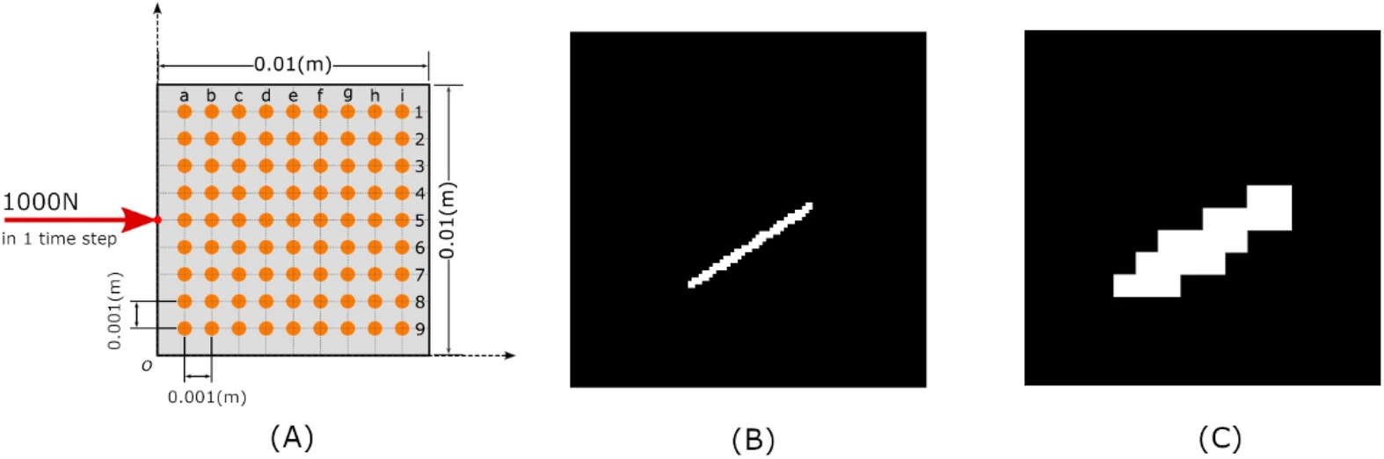
The source is moved along the boundary with an impulse load of 1000 N applied for a 1-time step(1 micro sec). The material properties are assumed to be 2GPa for elasticity and 0.3 for the Poisson ratio.

The crack is a static definition with propagation, the wave generated by the impulse load interaction with waves bouncing from the surface and are recorded at these 81 points (X and Y displacements)


More details are available in the paper with figures and explanations.
https://www.nature.com/articles/s41598-021-00326-2

What we have done so far is a single crack placed in the body and we excited the plate at the boundary. What we want is similar excitation but with multiple cracks.

